cloud computing
LAB 04

Name: Abiha Nadeem

Roll no: 2023-BSE-001

Submitted to: Engr. Muhammad Shoaib

Virtualization & Linux Fundamentals

Task 1 – Verify VM resources in VMware

Confirm the VM resources that were allocated in Lab 1.

Steps

- Open VMware Workstation and locate the Ubuntu Server VM you used in Lab 1.

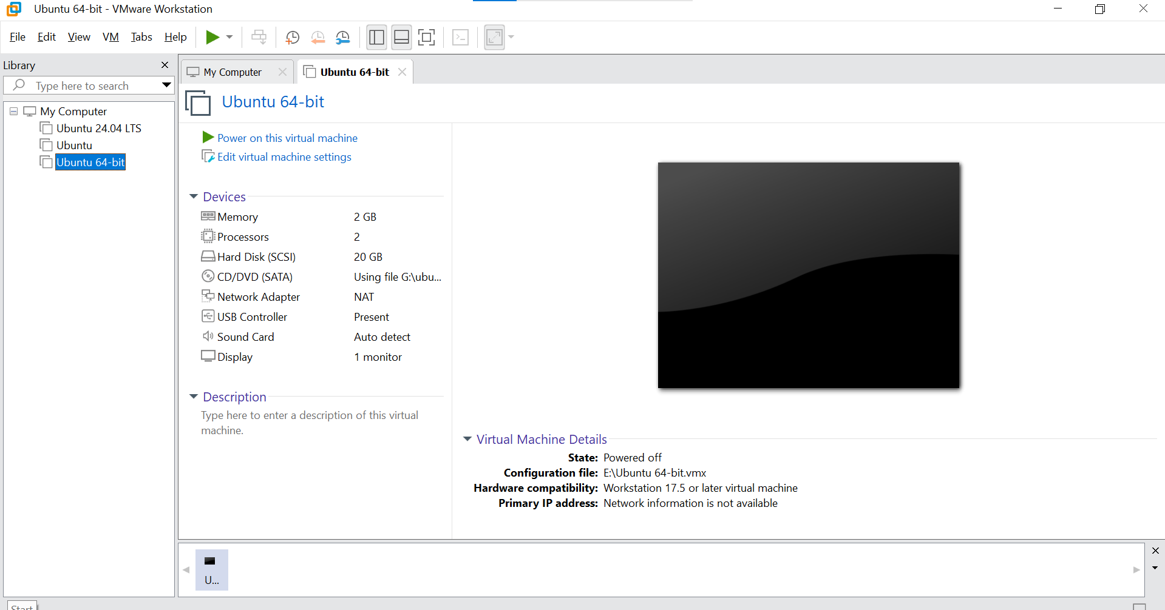

- Inspect VM settings and note the following (no commands required for GUI): VM name, RAM, CPU, disk, and network adapter type.

- Take a screenshot of the VM settings window showing RAM, CPU, disk and networking. Save screenshot as:

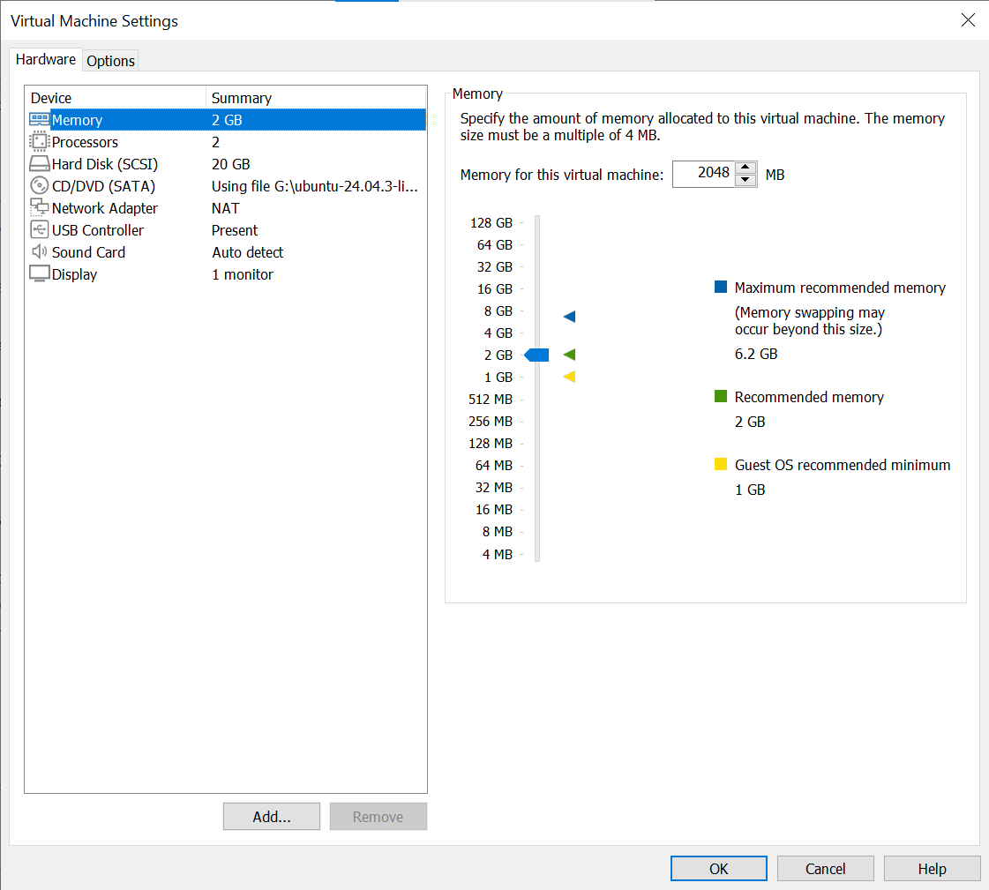

Task 2 – Start VM and log in (use your preferred host terminal method only)

Use a single preferred host-terminal method to connect to the VM. Do not switch between methods during the task.

Steps

- Start (or resume) the VM in VMware Workstation on your host.

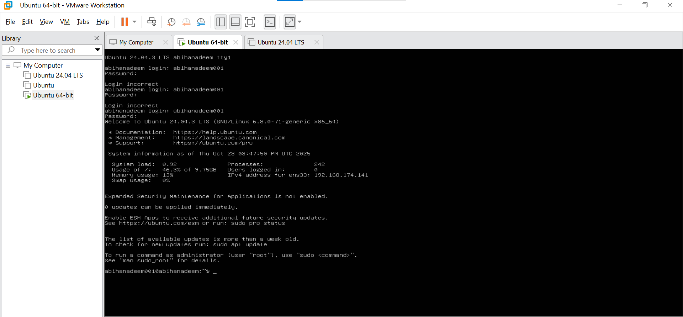

- From your host, open your preferred terminal (for example: Windows Command Prompt, PowerShell, macOS Terminal, or Linux Terminal) and connect to the VM using SSH. Example:

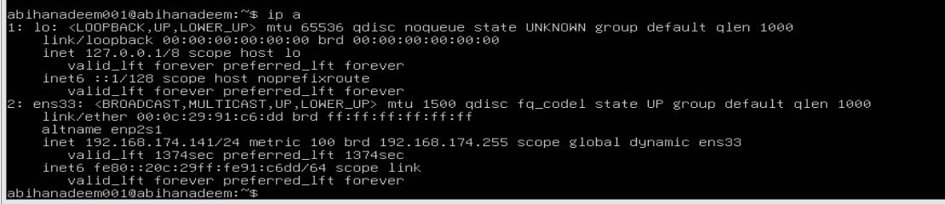

- After connecting, save a screenshot of your host terminal showing the SSH login prompt/results as: vm_login.png

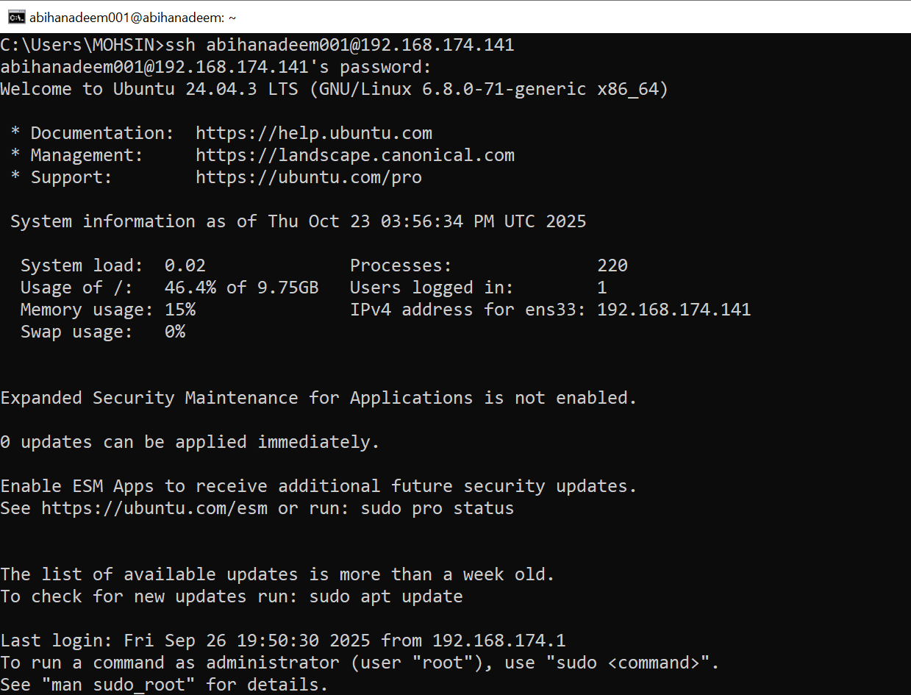

- After logging in, run both commands and capture them together in a single screenshot:

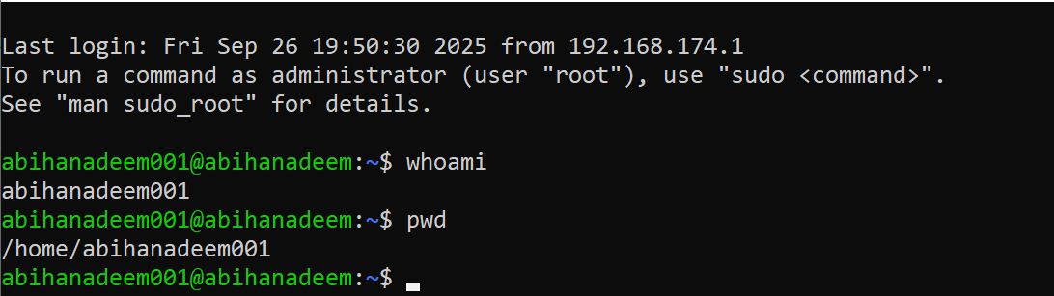

Task 3 – Filesystem exploration — root tree and dotfiles

Steps (run inside VM terminal)

- List root directory contents:

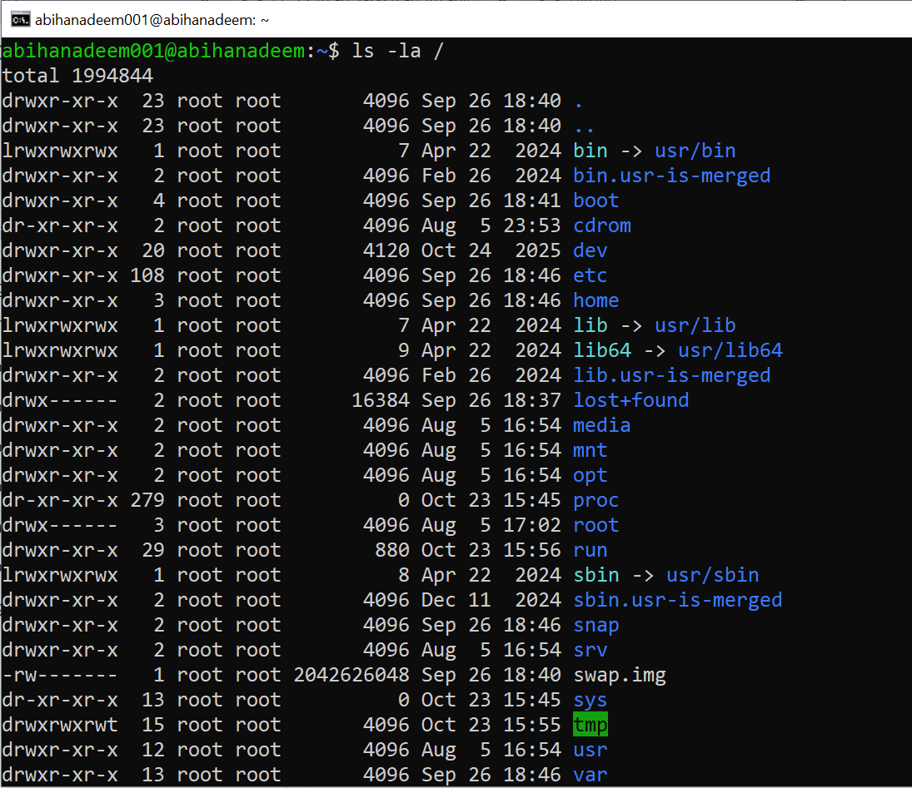

- Inspect these directories (run each command and screenshot the output):

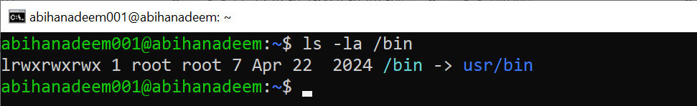

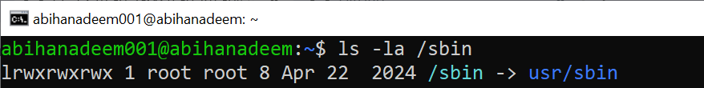

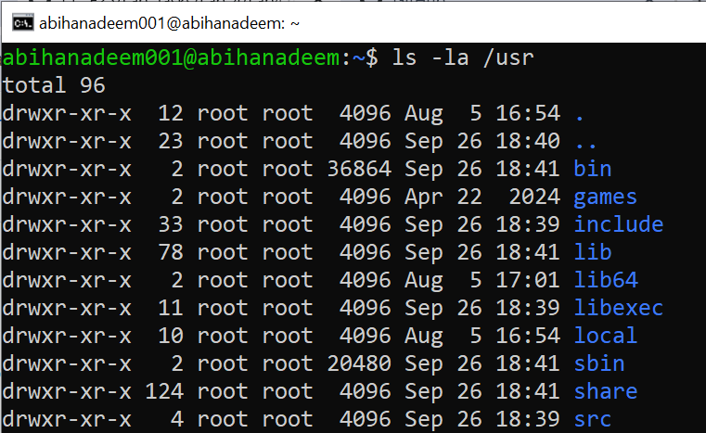

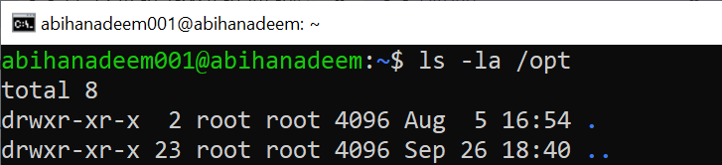

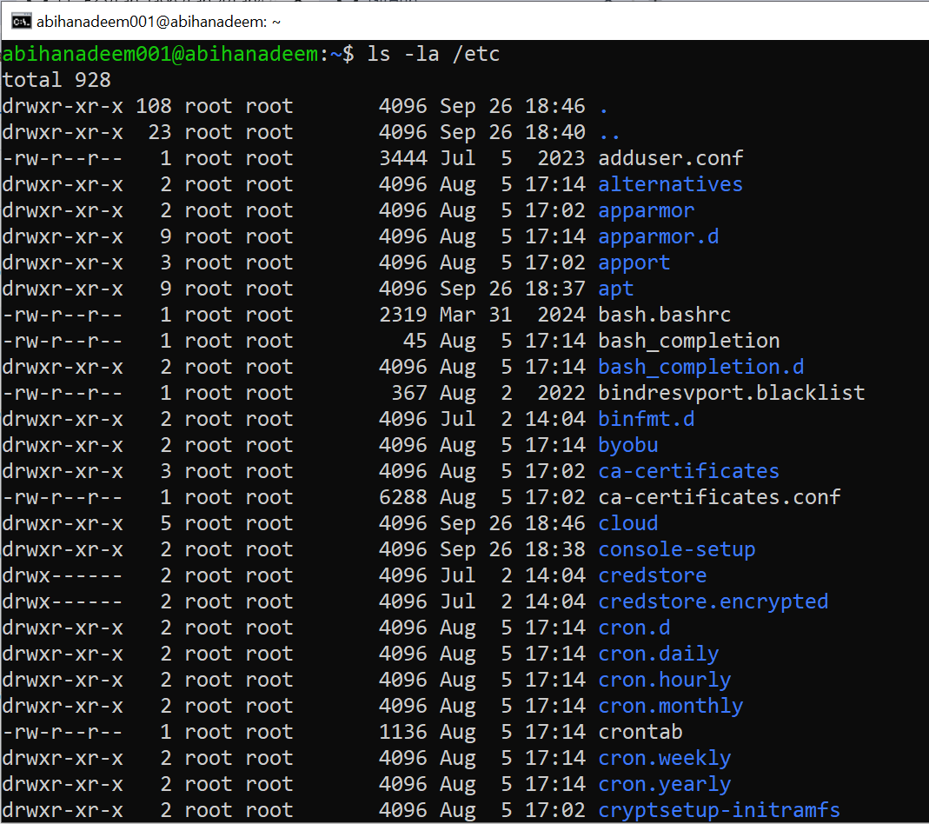

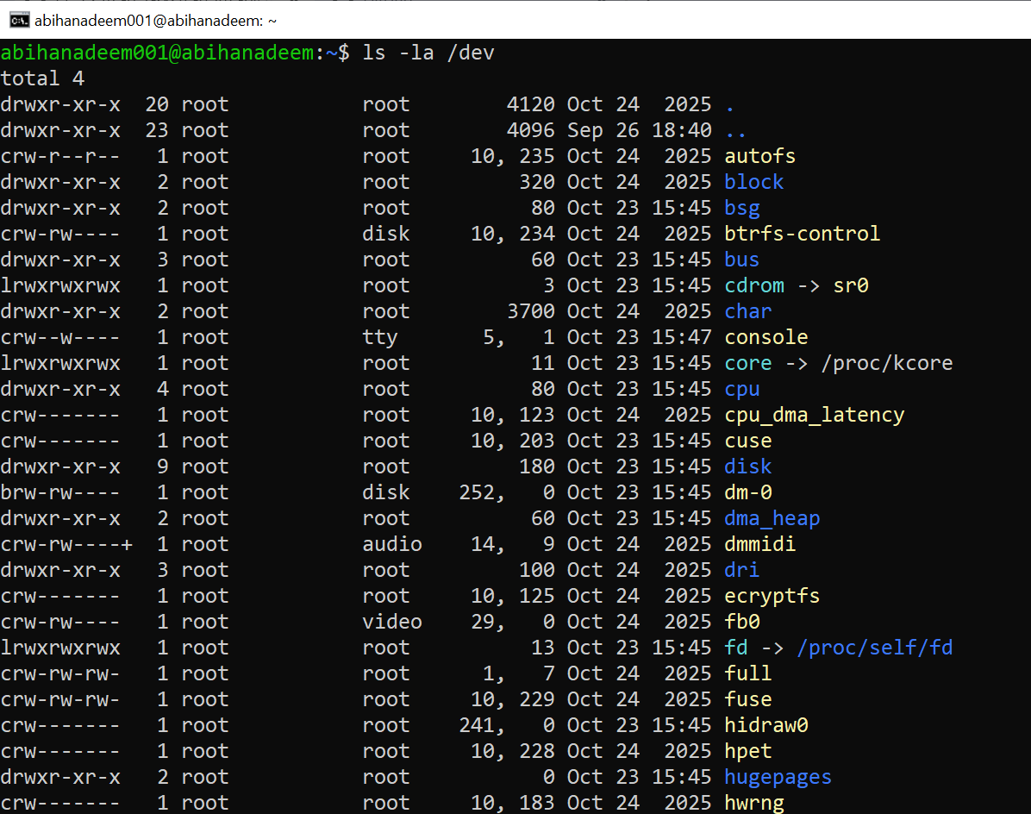

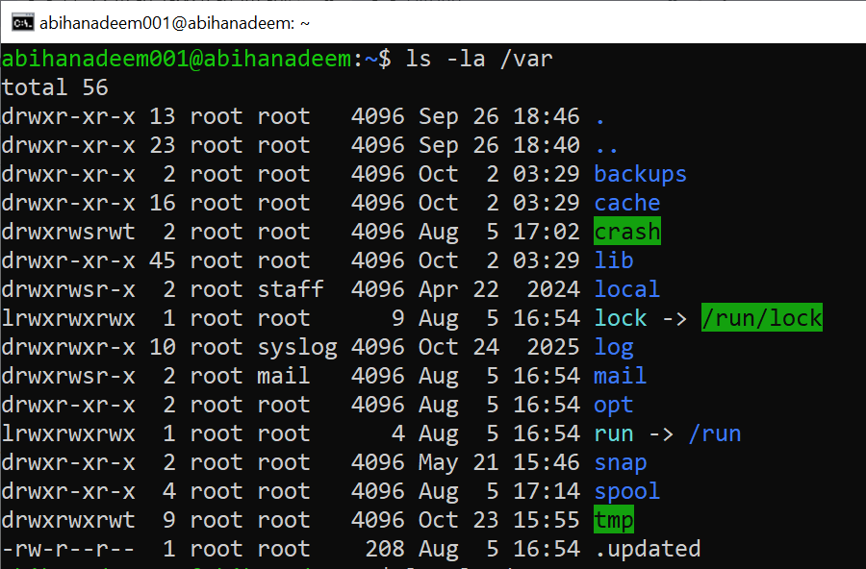

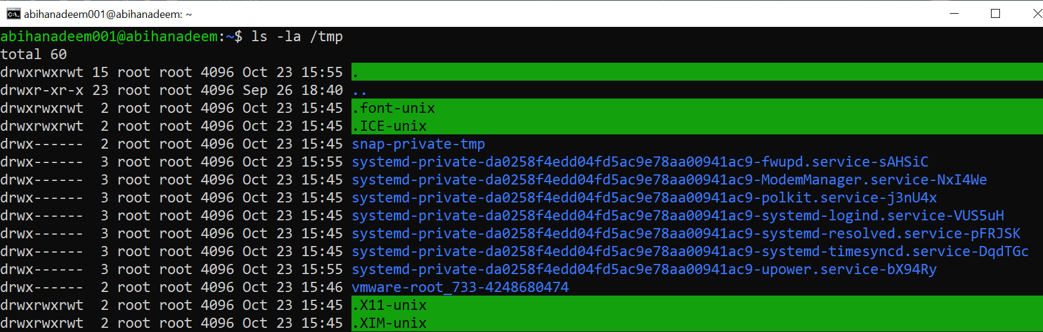

- List your home directory and show hidden (dot) files:
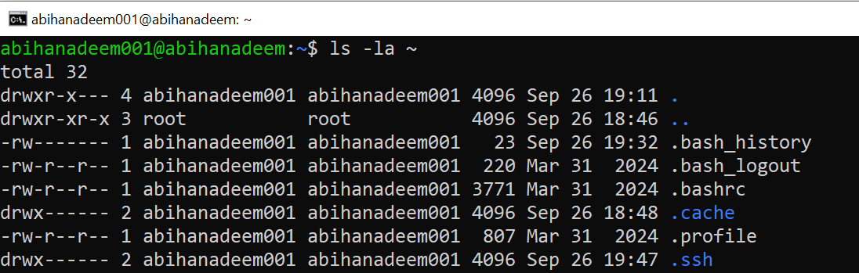
- Write a short paragraph (3–5 sentences) that explains the difference between /bin, /usr/bin and /usr/local/bin. Open your editor:

nano ~/answers.md

- Type the paragraph in the editor, save and exit.

- After saving, open the editor display (or show the file) and capture a screenshot of the paragraph. Save that screenshot as: answers_md.png

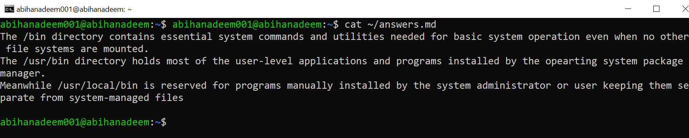

Task 4 – Essential CLI tasks — navigation and file operations

Steps (inside VM terminal)

- Create a workspace and navigate:

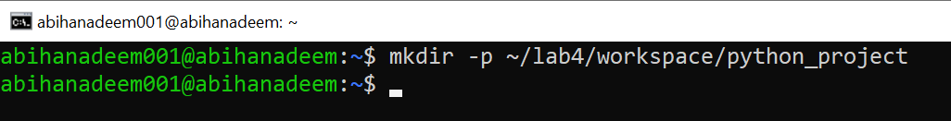

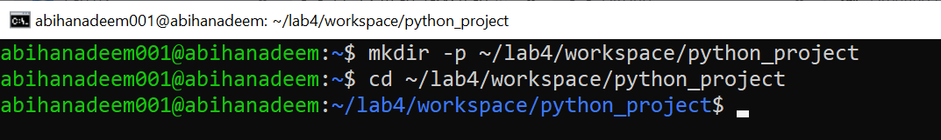

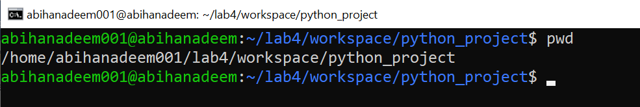

- Create files using an editor (open each editor session and save a screenshot showing content):

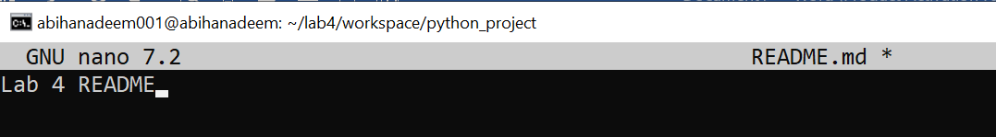

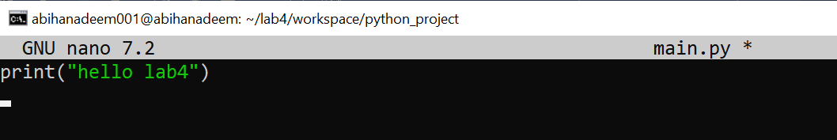

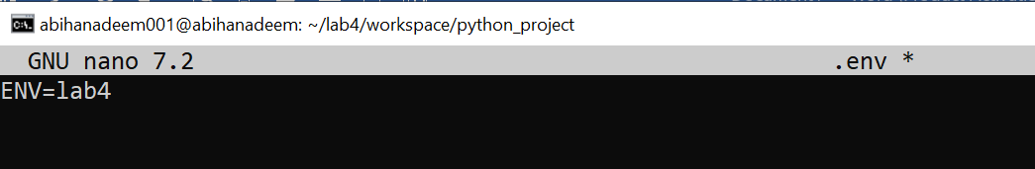

- List files and capture:

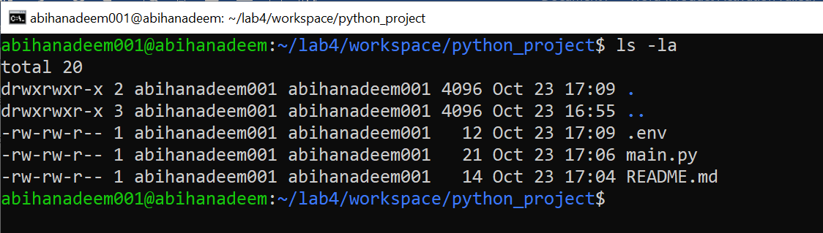

- Copy, move and remove:

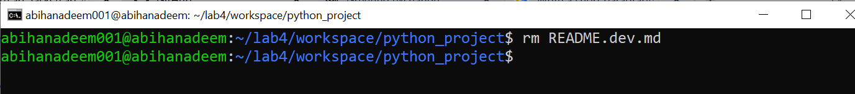

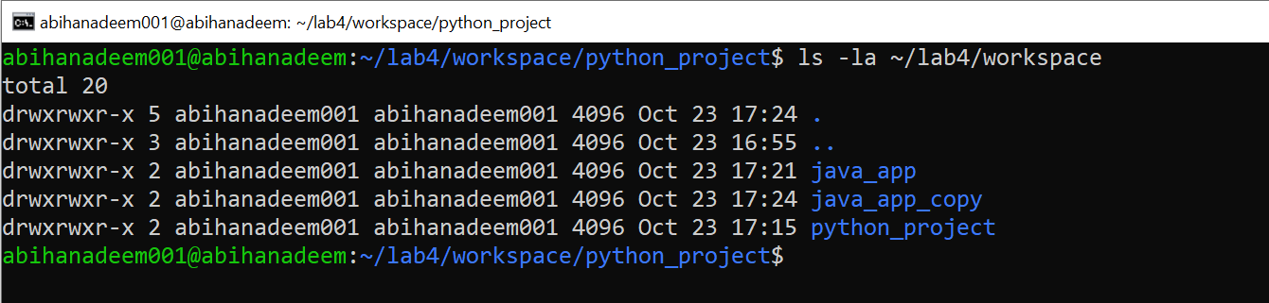

- Use command history and tab completion:

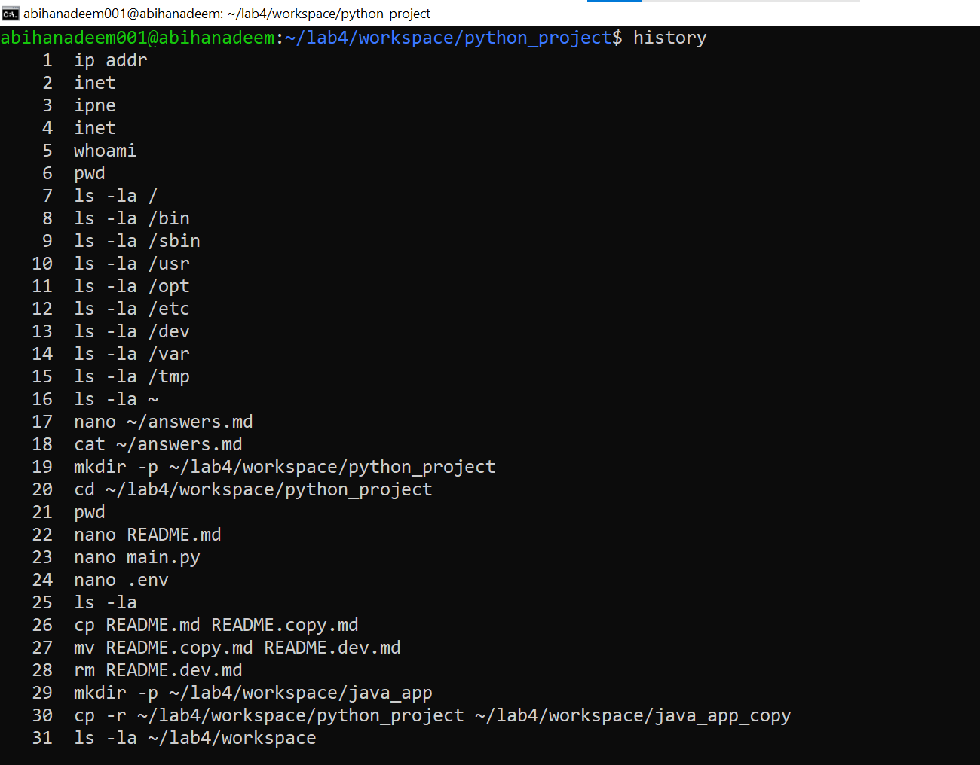

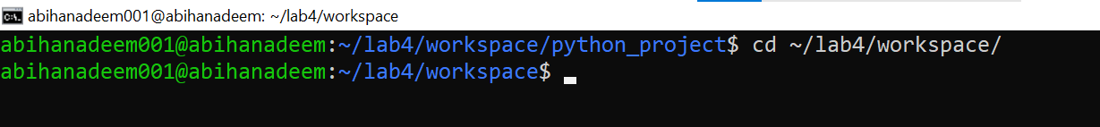

Task 5 – System info, resources & processes

Collect system information and observe processes. Use screenshots only.

Steps (inside VM terminal)

- Kernel and OS:

- CPU (ensure model name visible):

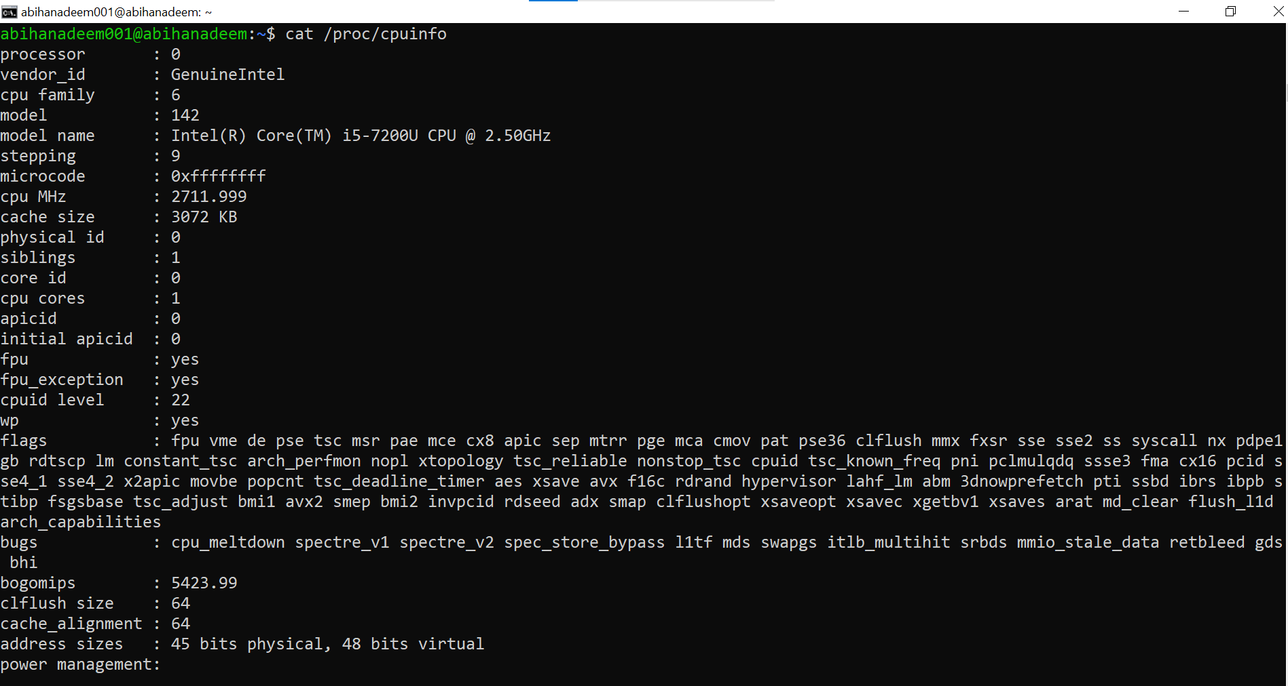

- Memory:

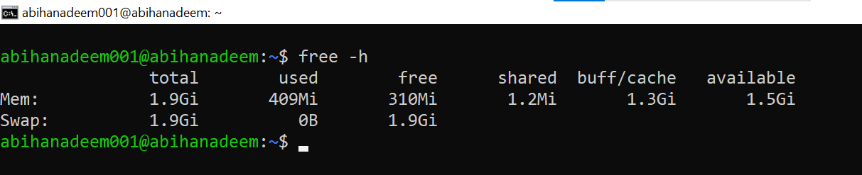

- Disk:

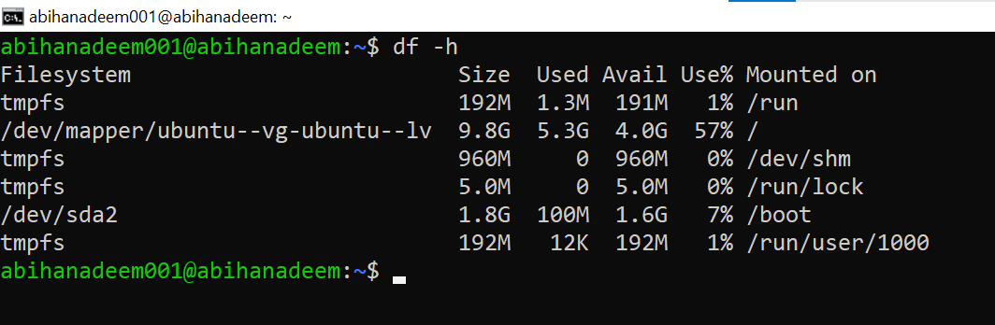

- View OS release information:

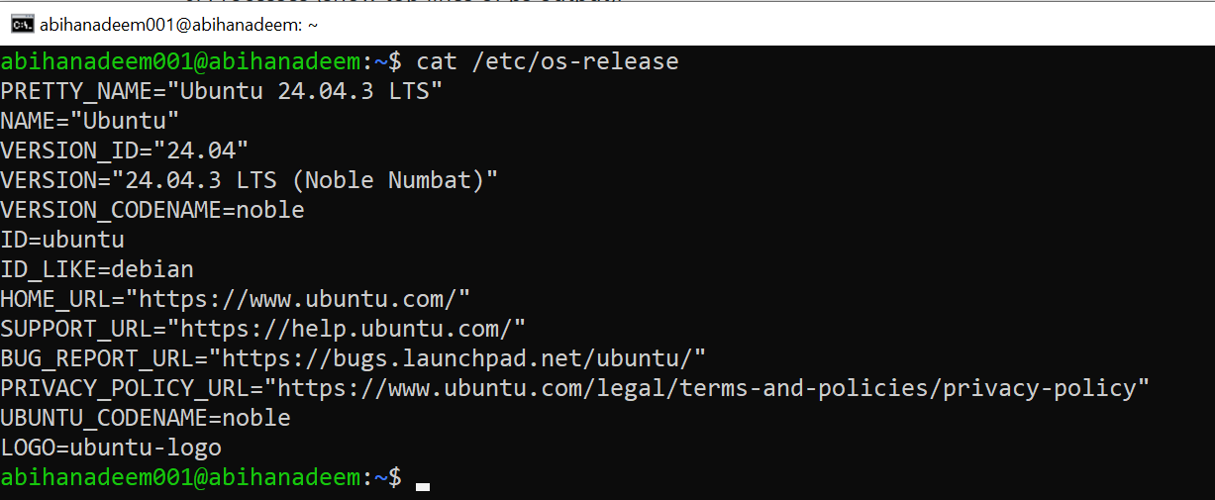

- Processes (show top lines of ps output):

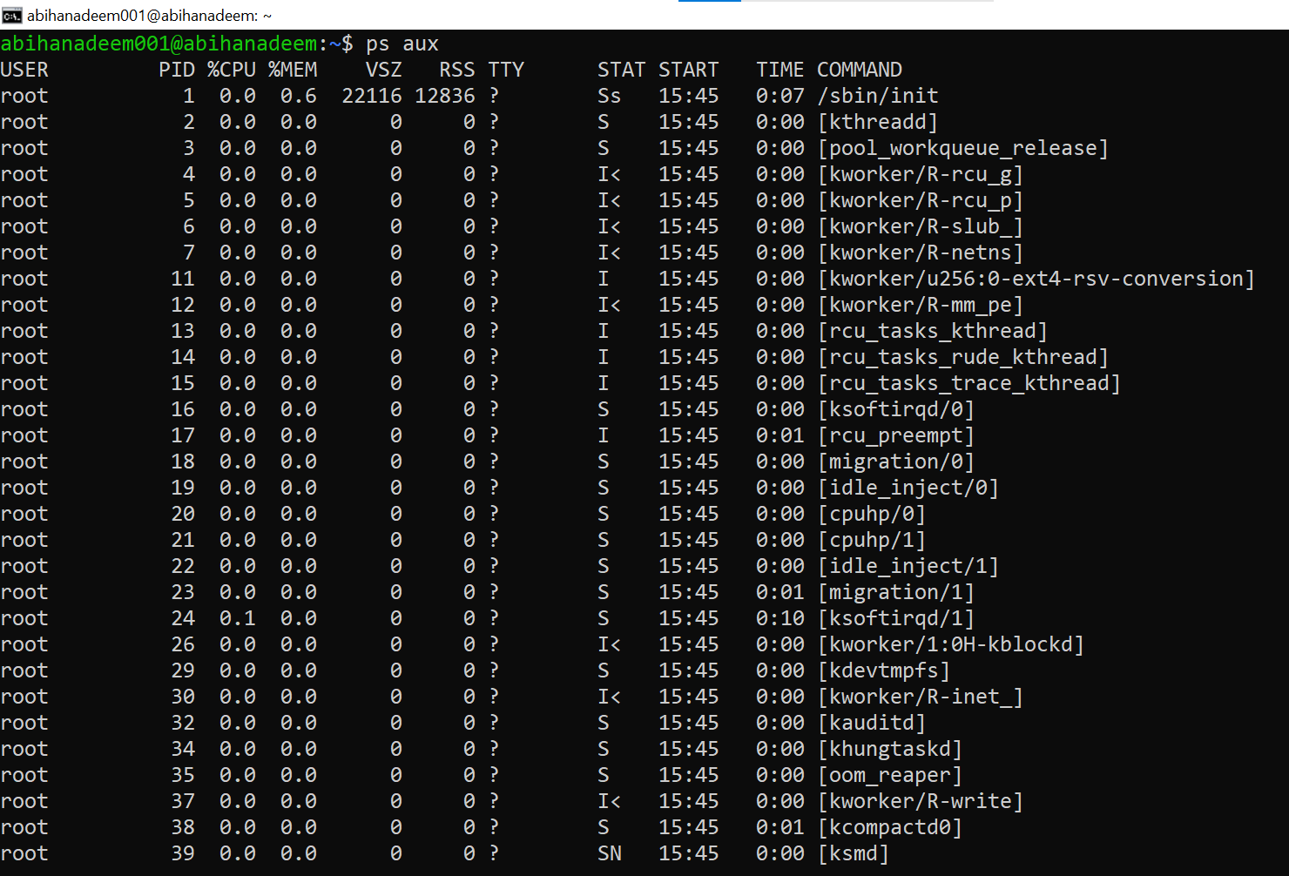

Task 6 – Users and account verification (no sudo group change)

Create a non-root user and verify the account exists. This task does NOT add the created user to the sudo group.
Steps (inside VM terminal)
- Create a new user named lab4user:

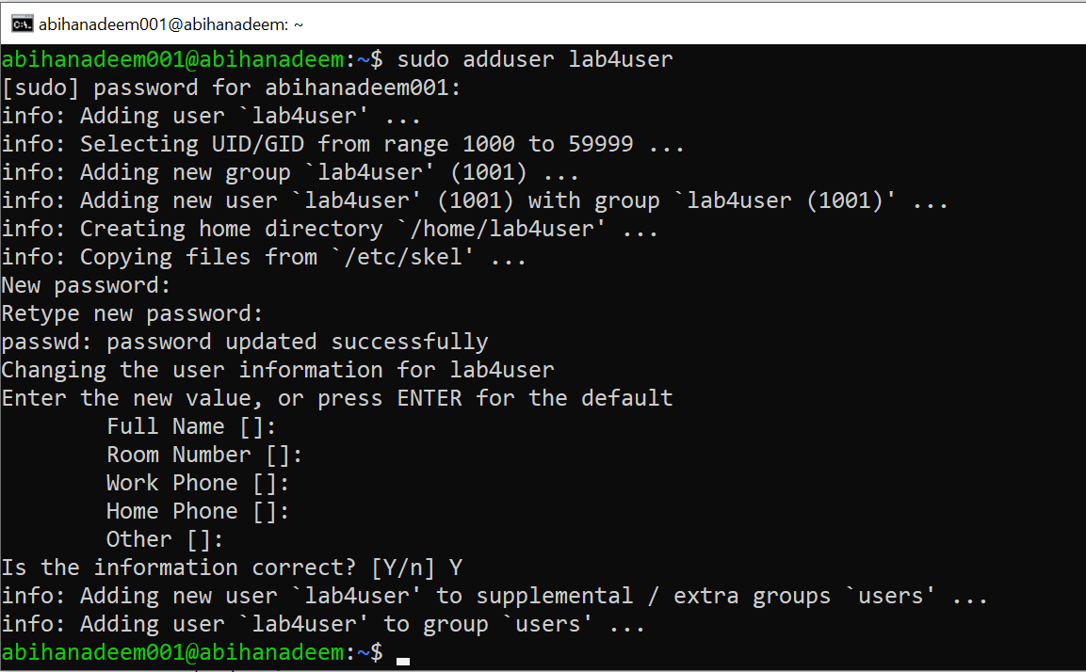

- Verify the user entry:

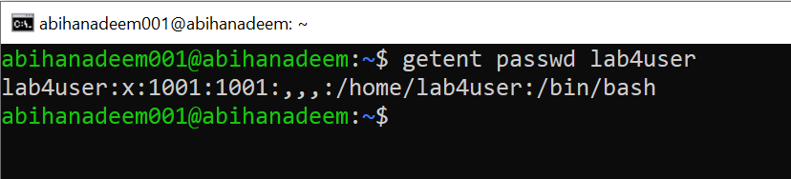

- Switch to the new user to verify login:

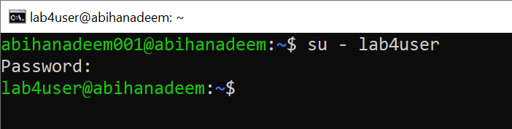

- From the new user you may attempt a sudo command to show that sudo is not available for this account (expected failure), e.g.:

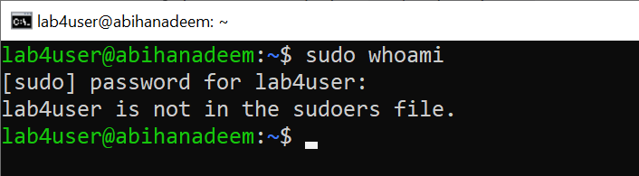

- Return to the original user:

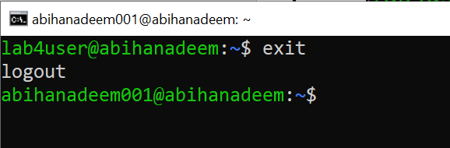

- (Optional) Remove the test user when finished:

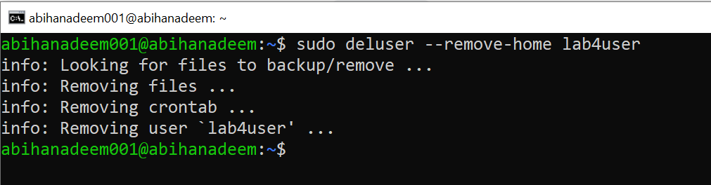

Exam Evaluation Questions

1. Remote Access Verification (Cyber Login Check)

Scenario:
You are part of a SOC (Security Operations Center) investigating unauthorized access to a Linux server hosted on VMware. Prove you can securely connect and verify your identity.

Steps:
- Connect to the Ubuntu VM remotely from your host terminal.
  - Screenshot as Q1_remote_connection.png

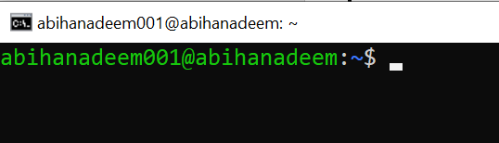

- Verify your current user and home directory path.
  - Screenshot as Q1_user_verification.png

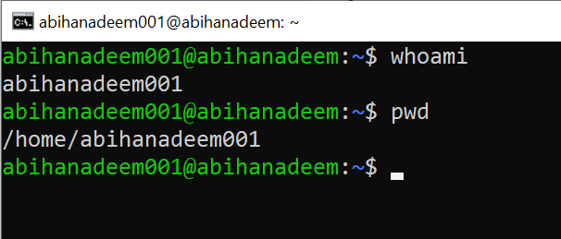

- Confirm you are connected to the correct host machine.
  - Screenshot as Q1_host_confirmation.png

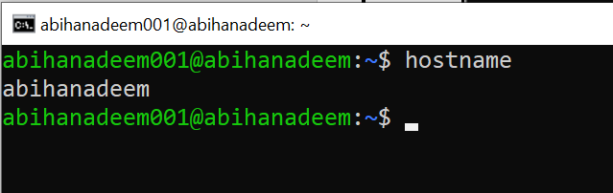

2. Filesystem Inspection for Forensic Evidence

Scenario:
The incident response team suspects malicious files in system directories. You must explore the filesystem to locate and document the system’s structure.

Steps:
- Display the contents of the root directory.
  - Screenshot as Q2_root_listing.png

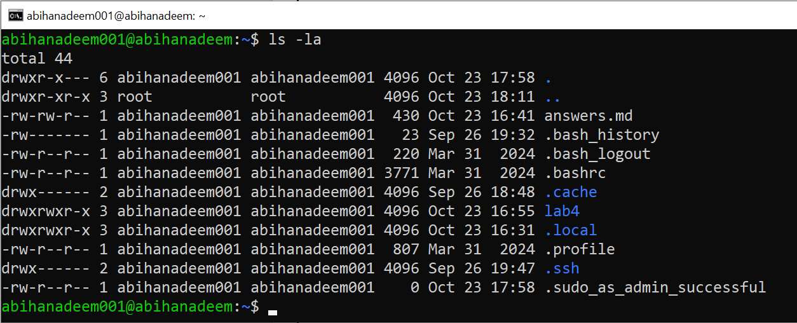

- Display the OS version and release information.
  - Screenshot as Q2_os_version.png

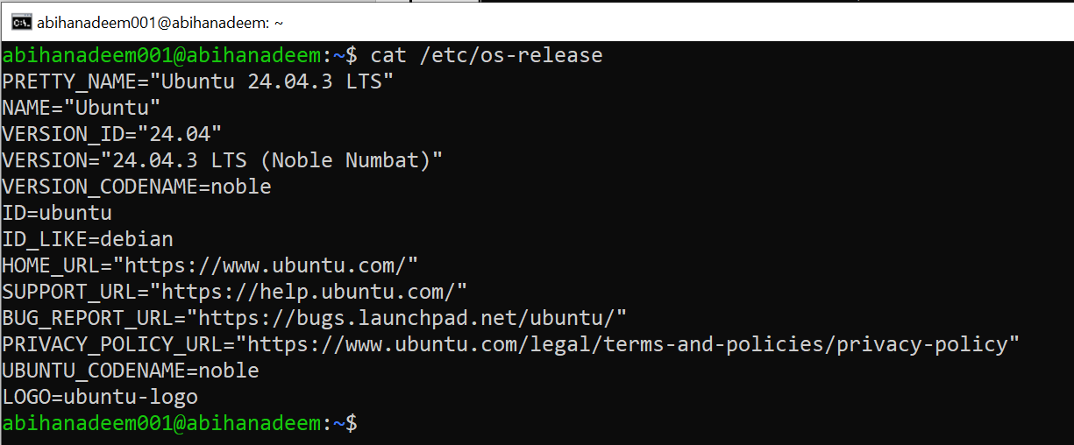

- Explore and record directory listings for /bin, /sbin, /usr, /opt, /etc, /dev, /var, and /tmp.
  - Screenshot as Q2_directory_evidence.png

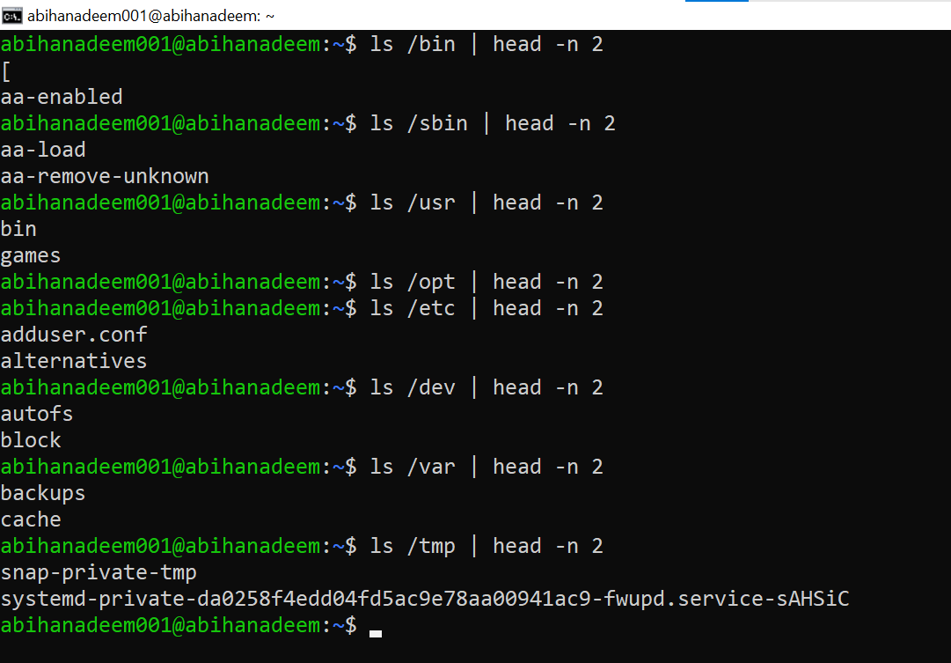

- Display all hidden files in your home directory.
  - Screenshot as Q2_hidden_files.png

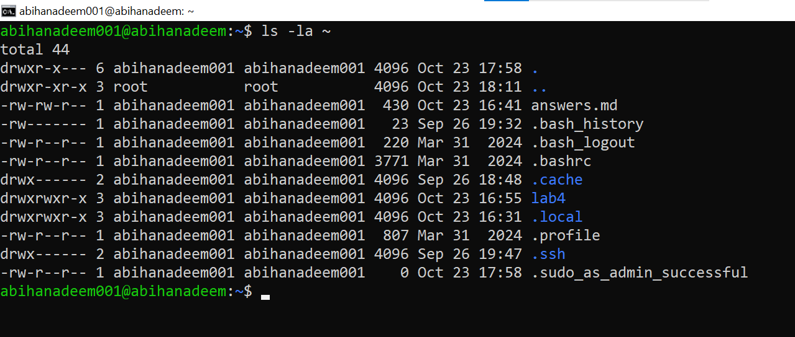

- Create a markdown file summarizing your findings on key binary directories.
  - Screenshot as Q2_report_file.png

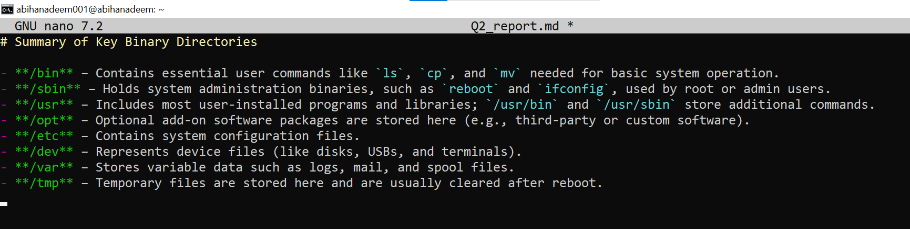

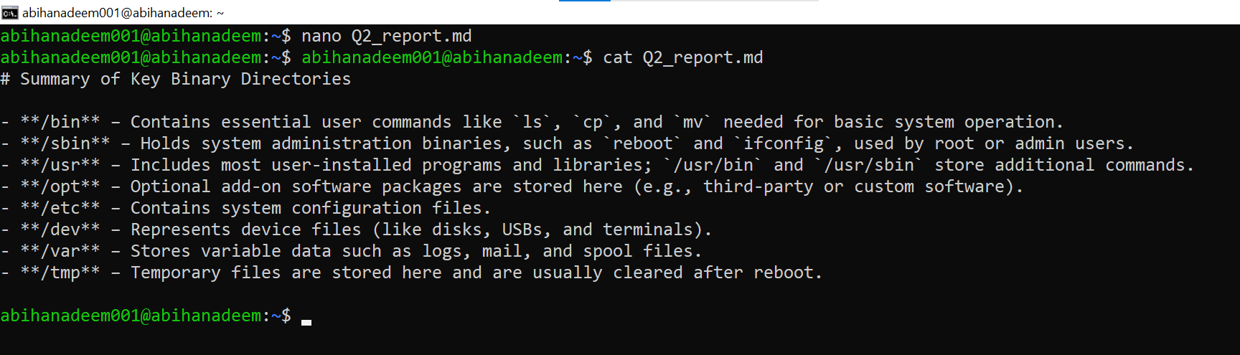

3. Evidence Handling & File Operations

You are creating a sandbox environment to safely analyze and handle suspicious files collected from a compromised system.
Steps:
- Create a structured folder hierarchy under your home directory for analysis.
  - Screenshot as Q3_workspace_created.png

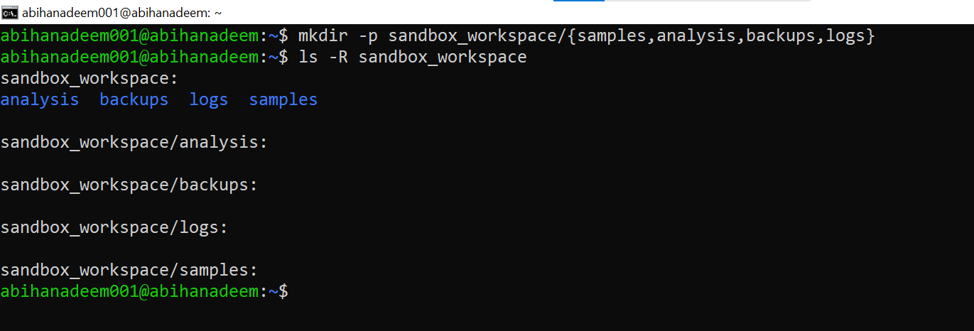

- Create three text files, including one hidden file, in your workspace.
  - Screenshot as Q3_files_created.png

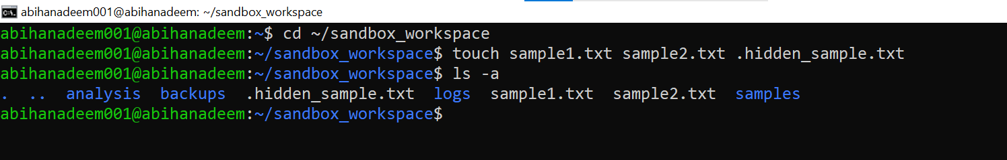

- Create a backup copy of one file, rename it, and then delete it after verification.
  - Screenshot as Q3_backup_handling.png

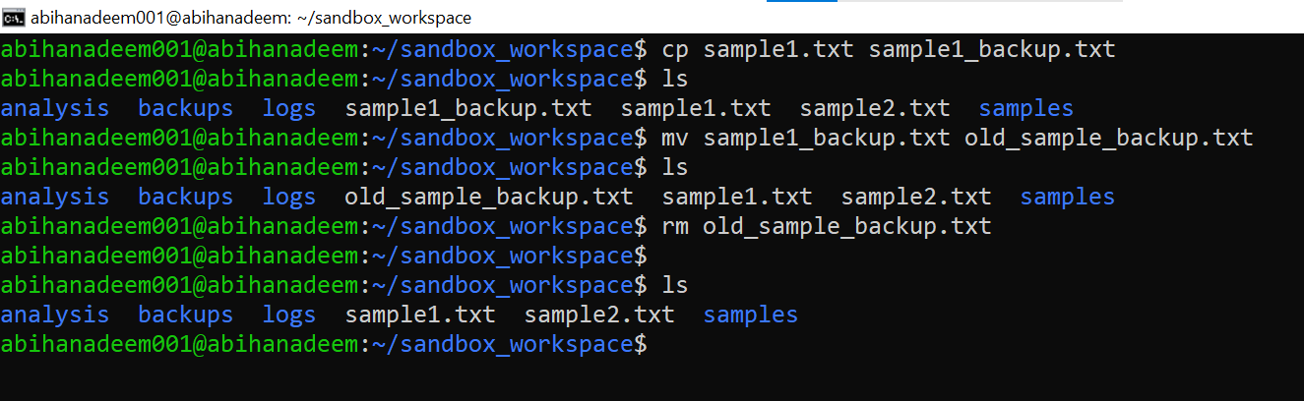

- Copy the entire workspace as an evidence backup folder.
  - Screenshot as Q3_workspace_backup.png

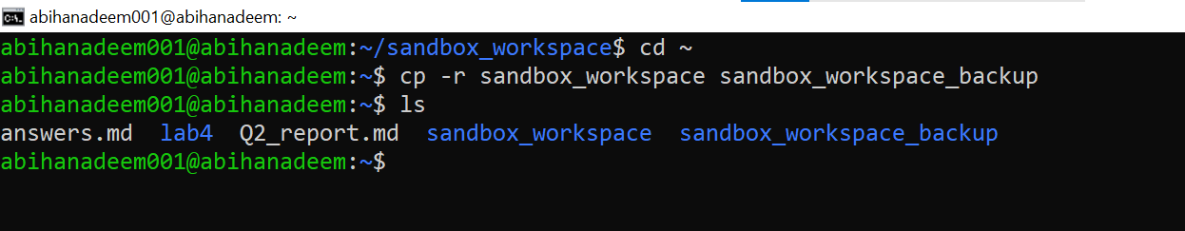

- Display your command history to document all actions performed.
  - Screenshot as Q3_command_history.png

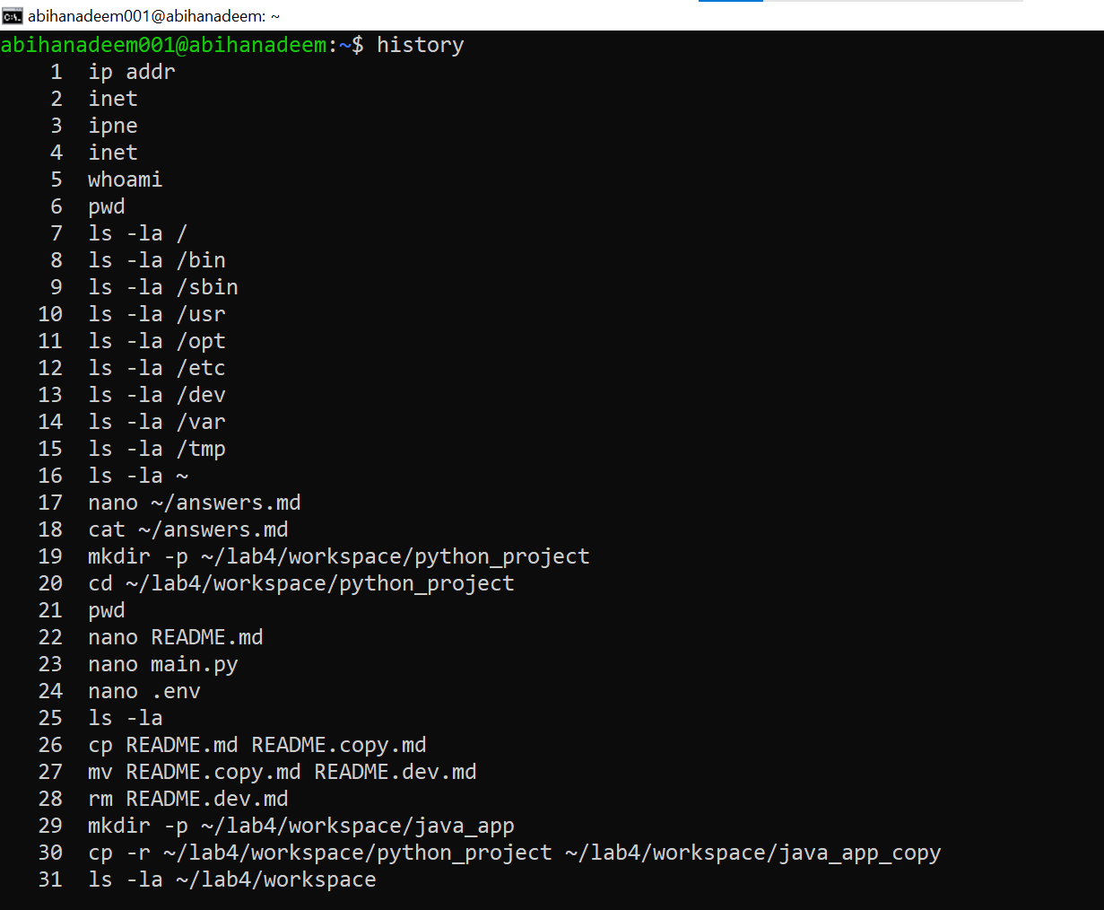

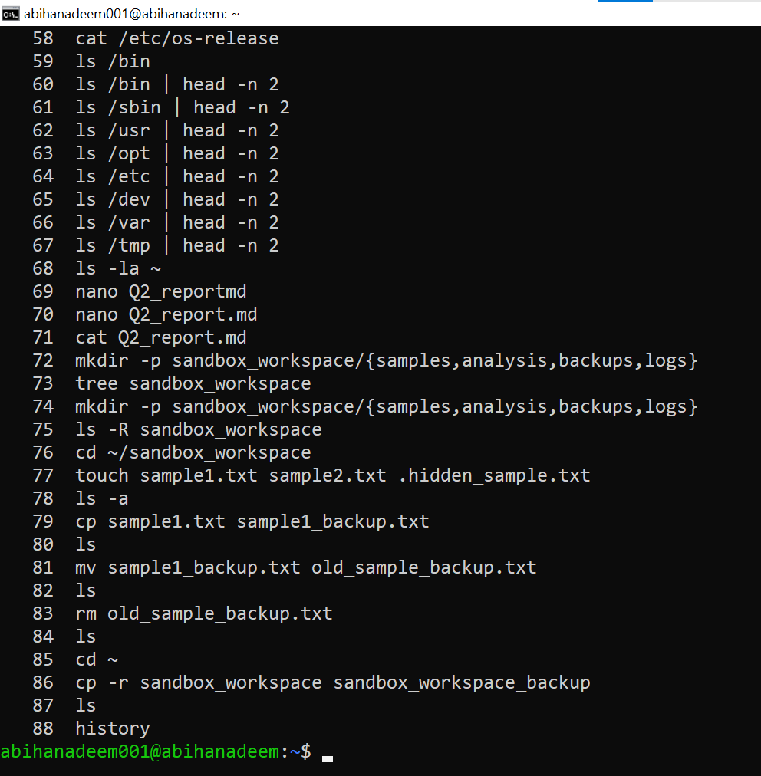

- Demonstrate Linux auto-completion by typing a partial command or filename.
  - Screenshot as Q3_autocomplete.png

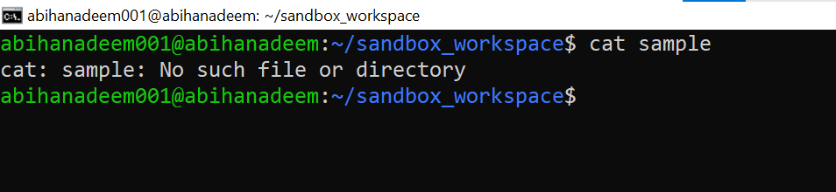
4. System Profiling and Process Monitoring
Scenario:
You are investigating a potential malware infection that is consuming excessive resources on the Linux VM.
Steps:
- Display the system’s OS and kernel version for the investigation report.
  - Screenshot as Q4_system_info.png

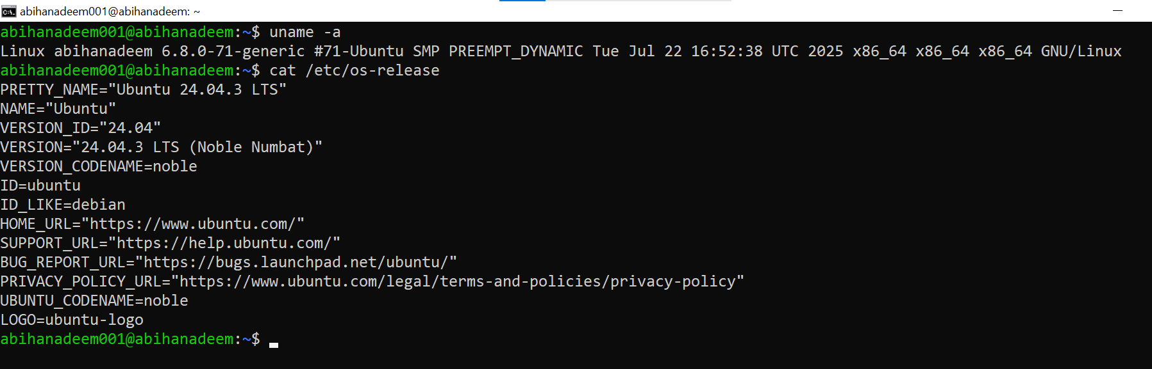

- Display CPU, memory, and disk usage information.
  - Screenshot as Q4_resource_info.png

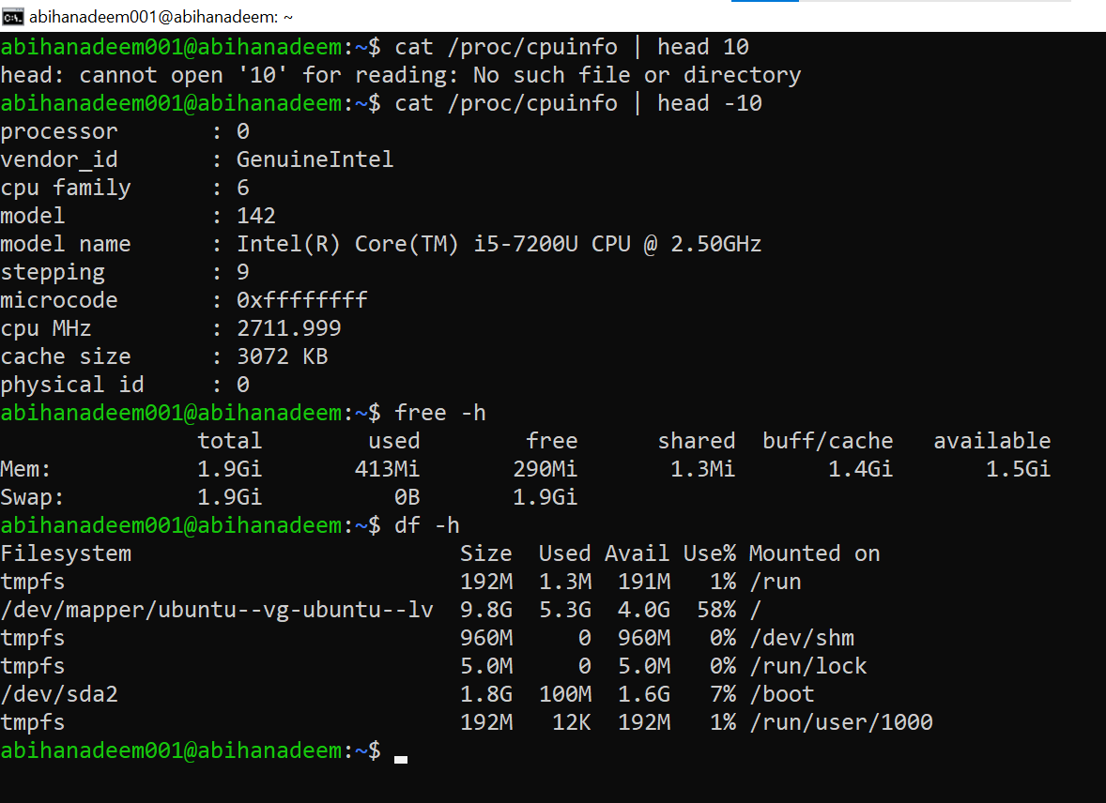

- Display all active running processes to identify suspicious activity.
  - Screenshot as Q4_process_list.png

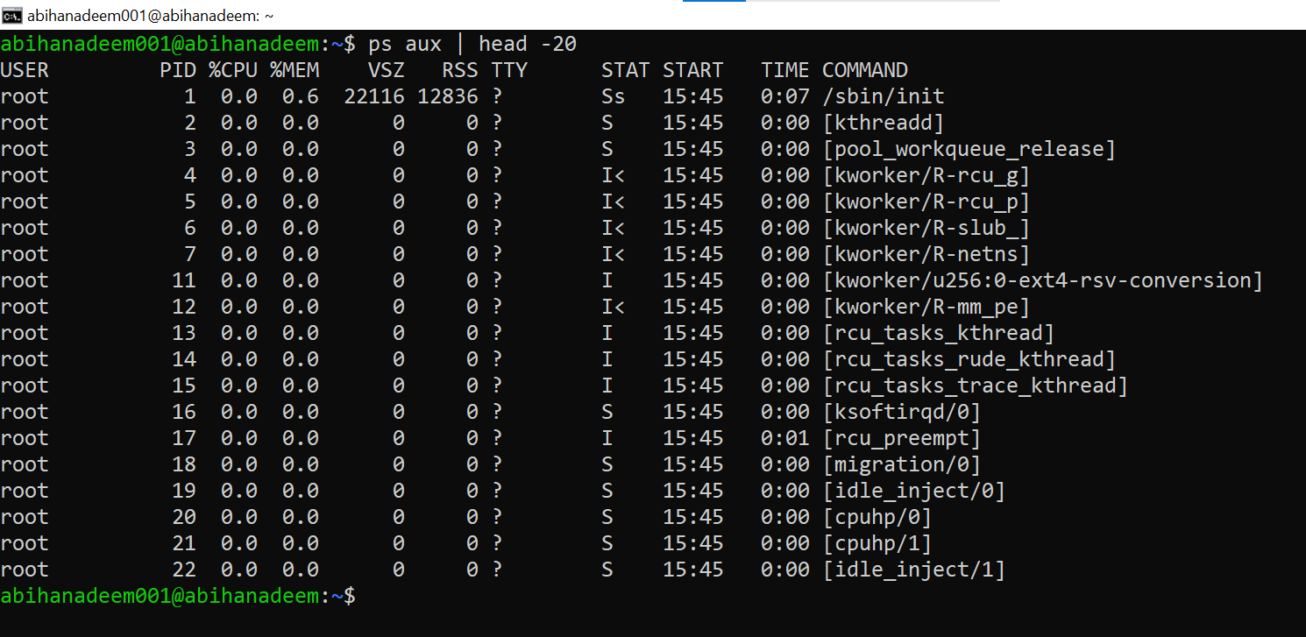

5. User Account Audit & Privilege Escalation Simulation

Scenario:
You are performing a user activity audit on a compromised Linux server.
The SOC suspects a newly created account (lab4user) may have been used for unauthorized access.
Your task is to simulate the account creation, perform privilege tests, and analyze authentication logs for forensic evidence.

Steps:
- Create a new test user named lab4user.
  - Screenshot as Q5_user_created.png

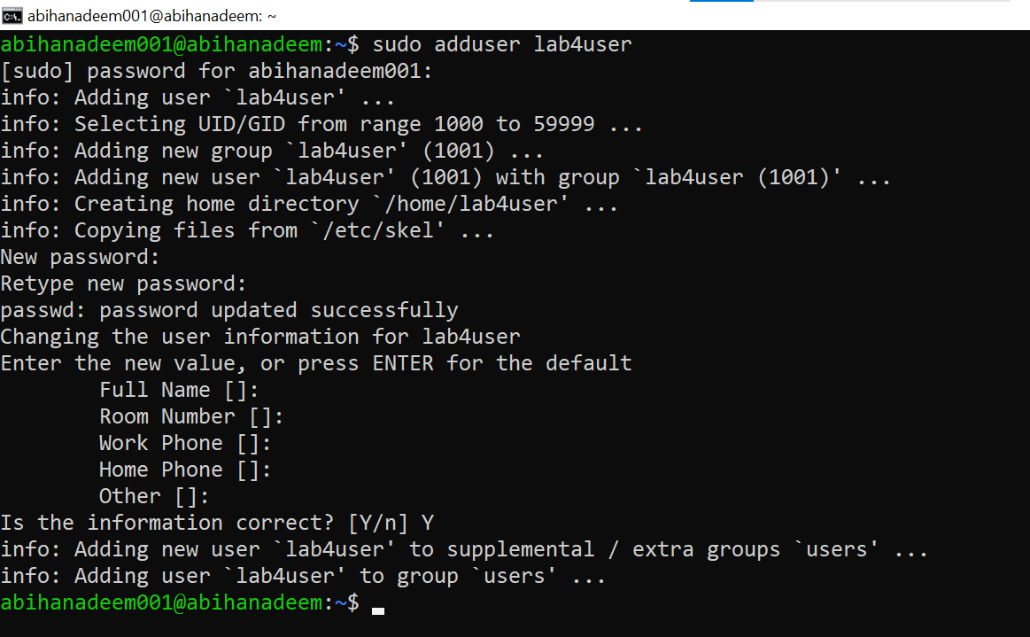

- Verify that the new user record exists in the system’s user database.
  - Screenshot as Q5_user_verified.png

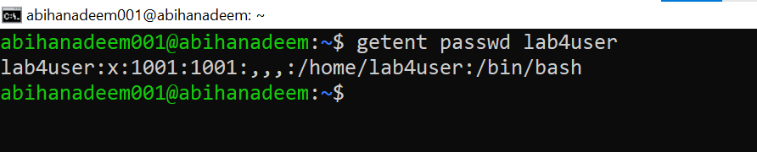

- Log in as lab4user and confirm successful login.
  - Screenshot as Q5_user_login.png

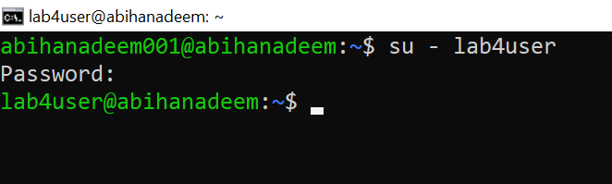

- Attempt to run an administrative command as lab4user (expect permission denied).
  - Screenshot as Q5_permission_denied.png

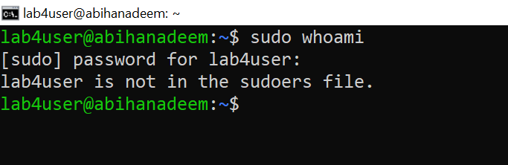

- Switch back to your main analyst account.
  - Screenshot as Q5_switch_back.png

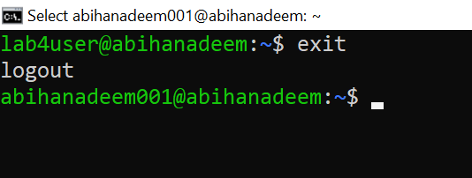

- Inspect the system authentication logs located at /var/log/auth.log to determine whether the lab4user account attempted any logins (successful or failed).
  - Screenshot as Q5_authlog_analysis.png

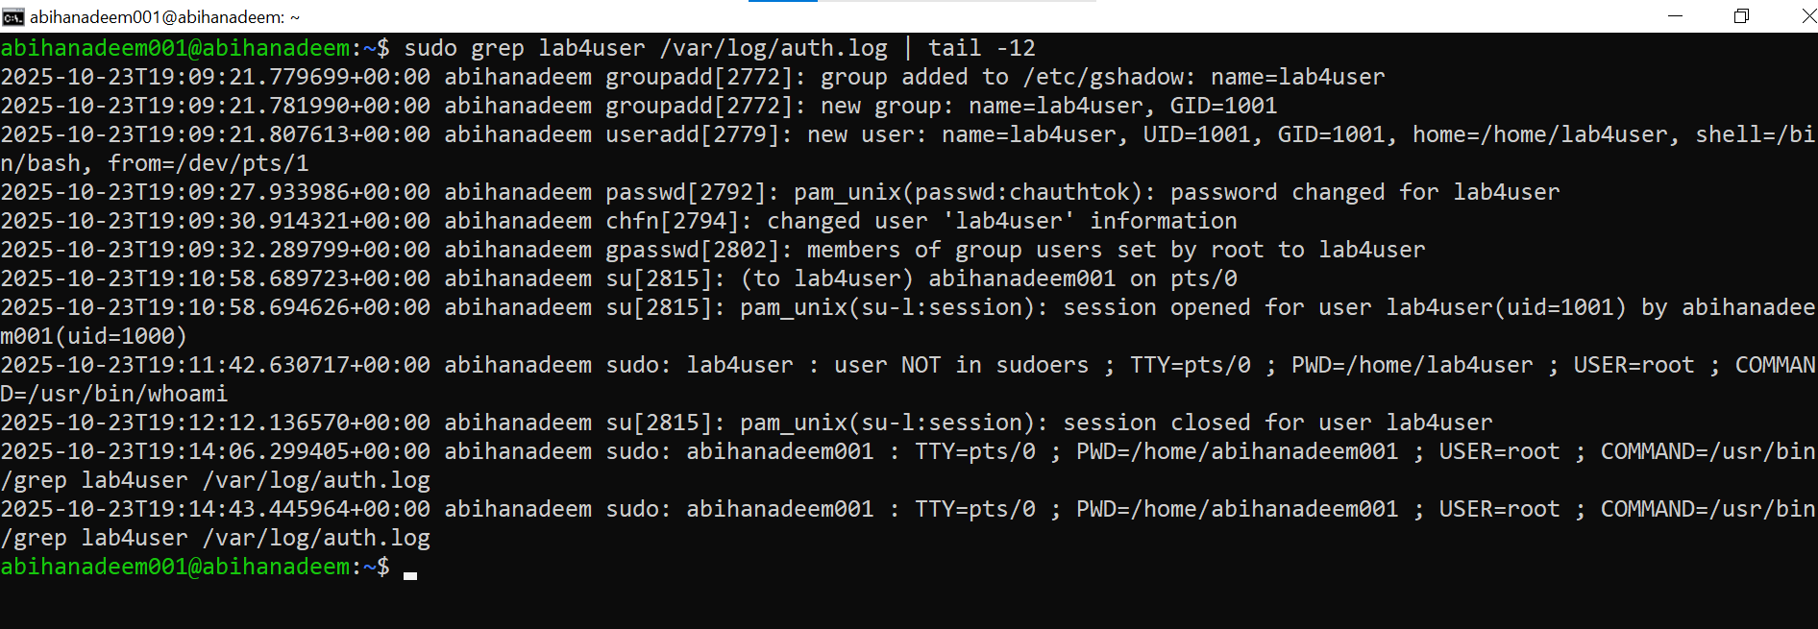

- (Optional) Remove the lab4user account after the audit and verify deletion.
  - Screenshot as Q5_user_removed.png





